Noise+Signal
'Noise is the ineluctable travelling companion of information.' (Hainge, 2013)

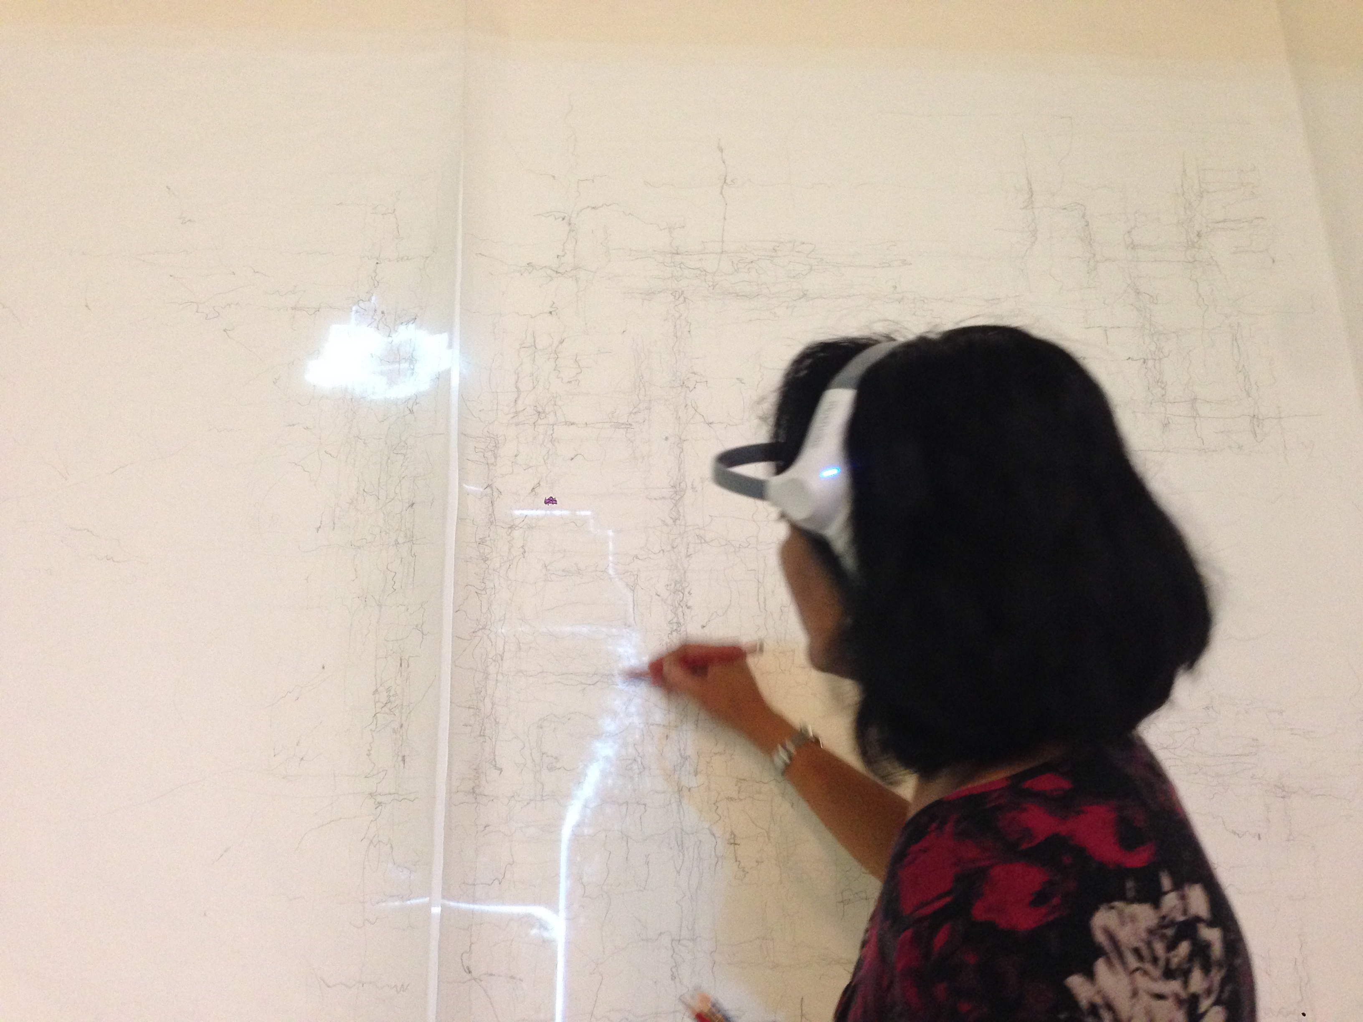
Drawing performance, FACT, Liverpool, Sept 2013

EXPERIENCE
All my senses are alert, listening out for the scent of the signal. I scan the surface of the paper trying to register movement at the edges of my perception. The body and hand responds in its own time; a different speed to the data. I anticipate and almost capture the projected signal, organising the lines into a new structure.

I am always out of step; the drawing evolves from off the side-lines, off centre. It is a trace of the almost captured. The live data has it's own rhythm and structure. My hands learn how to connect with this unpredictable and fleeting line. Neurons reconfigure as I process the signals from alpha, beta, and theta waves...

A new visual code evolves, as one system generates another. Its symbols are the enclosed line, the open trailing line, and the repeated line. I allow the collision between the speed of the data and the pace of my body to manifest itself through the pencil. Pressure and movement become my tools. Hesitations become a series of dots punctuating quick, darting lines that speed off out of control. Slower marks hint at my uncertainty and my unknowing. These lines retrace missed signals, following pathways by memory. Smudges, creases, the marks of my hand upon the paper evidence the encounter between signal and body.

Some drawings resemble electrical circuitry and diagrams. Others suggest an organic, pulsing, meandering trail. They are maps of the unknown, maps of losing my way through the data.

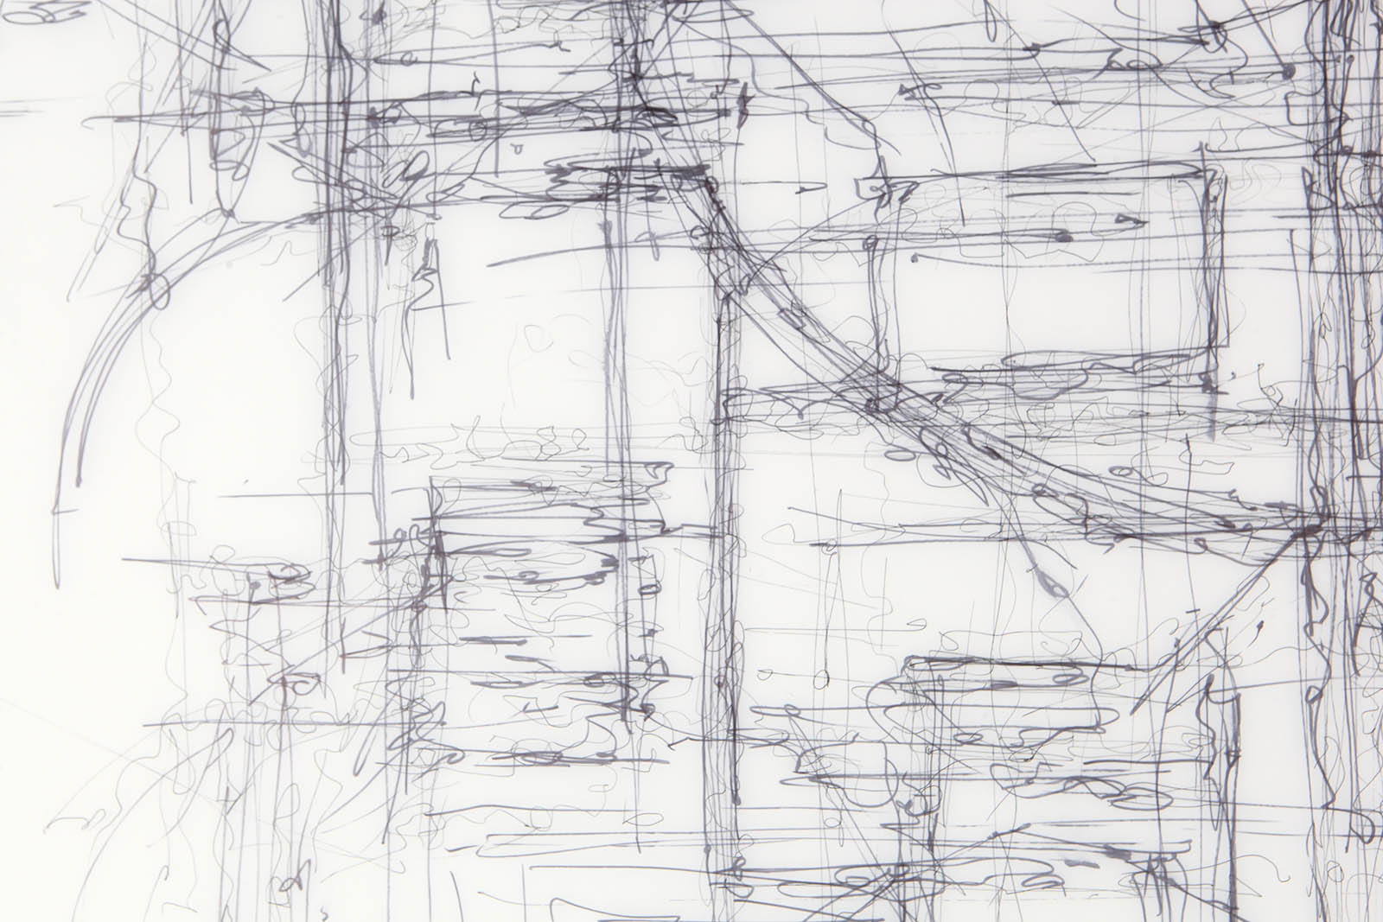
Detail from drawing at FACT, Liverpool, September 2013

CONTEXT
The ‘Niose+Signal’ project is an on going series of performative experiments testing methods for visualising bio-information through the process of drawing. They take place within different cultural institutions and are open to the general public, who are invited to participate in the experiment. The project is an exploration of the relationship between 'noise' and 'signal' in bio-data, and sets up alternative methodologies for engaging with and representing bio-data. 'Noise' in this context is understood as unintentional, unverifiable or unknown signals generated by technologies during the process of data transmission, as well as, unknown signals generated by the human body. According to Hainge (2013), noise is oppositional and undermines notions of complete (scientific) knowledge.

Detail from drawing performance at Manchester Metropolitan University, August 2013

During the performance, the participant and the artist are connected to biosensors, which transmit signals in real time via a projector onto a large sheet of paper. Participants move freely around the building (within wifi range), whilst the artist records the projected signal by drawing upon the paper. The participant wears a skin galvanometer, which detects changes in skin conductivity as a result of varying levels of moisture upon the skin. This measurement is widely understood as an indication of emotional arousal. The artist is connected to an EEG headset (Neurosky Mindwave), which measures levels of concentration and relaxation. The headset consists of a single sensor positioned in the centre of the forehead, which detects beta and gamma waves (levels of concentration) and alpha and theta waves (levels of relaxation).

EEG and skin galvanometer readings are typically visualised as a series of continuous lines that rise and fall in line with measurement levels. This style of imagery makes reference to graphs, mathematical formulae and has associations with objective, factual knowledge. To counter this, a creative coder was commissioned to develop new methods of visualising the bio-data. The new code translates the bio-information into a set of variables that trigger changes in a baseline image: an architectural drawing of the space, produced by the artist, which is vectorised and scanned into the system.

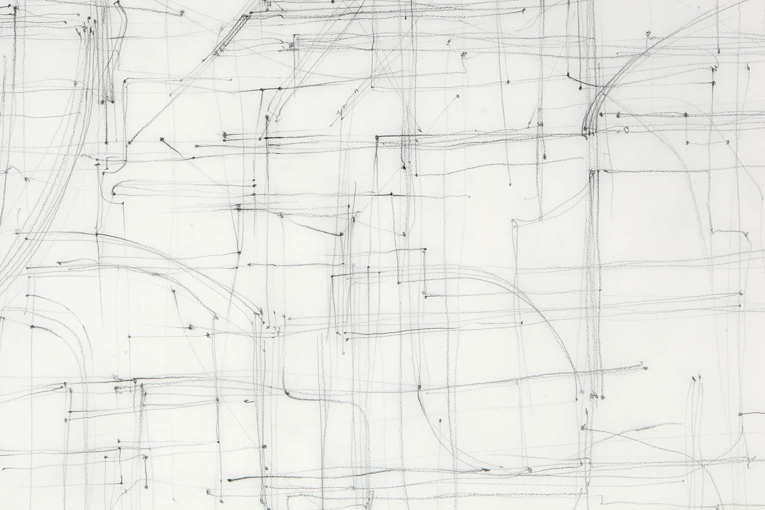
Detail from drawing performance at Cornerhouse, Manchester, October 2013

Data from each participant's sensor triggers a set of pre-programmed variables as it interacts with data from the artist's EEG headset. The variables control the speed, direction, and quality of movement of the projected line. If bio information is not present in the system, the visualisation follows the line of the drawing faithfully as a predetermined path. However, sensor data triggers changes in this process, rendering the image unpredictable and unknown. The whole drawing does not reveal itself at any one time; only partial and fragmentary views are possible.

In this system, the object of the study - the participant - becomes an agent in their own measurement through the actions of their own bio-data. Furthermore, the system acknowledges the presence of the observer and recorder (the artist) by also implicating their data in the process. This 'conversation' between the two sets of data is the catalyst that produces varying levels of 'noise' in the system.

Each performance produces different types of drawings, not only as a result of changes in the data, but also as a result of modifications in the artist's drawing style. This is an explicit response to new locations, and different experiences of place and space.

